Early Tetrapodomorph Biogeography: Controlling for Fossil Record Bias in Macroevolutionary Analyses

Jacob D. Gardner, Kevin Surya, and Chris L. Organ

Supplementary Materials

Table of Contents

1. Supertree
1.1. Data
1.1.1. Morphological data matrices 1
1.1.2. Tip dates 1
1.1.3. Root calibrations 3
1.2. Analyses
1.2.1. Bayesian phylogenetic inference 3
1.2.2. Distance supermatrix 4
1.2.3. Unweighted neighbor-joining 4
1.2.4. Rooting and plotting 5
1.2.5. Tree comparisons 5
2. Phylogeography
2.1. Data
2.1.1. Paleocoordinate locations 6

Supplementary tables
Table 1: Data matrix summary 1
Table 2: Tip dates 2
Table 3: Average standard deviation of split frequencies values 4
Table 4: Average normalized Robinson-Foulds (nRF) distances 5
Table 5: Taxon paleolocation sources 6

Supplementary figures
Figure 1: The phylogenetic tree inferred using Friedman et al.’s (2007) matrix 9
Figure 2: The phylogenetic tree inferred using Swartz’s (2012) matrix 10
Figure 3: The phylogenetic tree inferred using Clack et al.’s (2017) matrix 11
Figure 4: The phylogenetic tree inferred using Pardo et al.’s (2017) matrix 12
Figure 5: The phylogenetic tree inferred using Zhu et al.’s (2017) matrix 13
Figure 6: The time-scaled phylogenetic tree inferred using Friedman et al.’s (2007) matrix 14
Figure 7: The time-scaled phylogenetic tree inferred using Swartz’s (2012) matrix 15
Figure 8: The time-scaled phylogenetic tree inferred using Clack et al.’s (2017) matrix 16
Figure 9: The time-scaled phylogenetic tree inferred using Pardo et al.’s (2017) matrix 17
Figure 10: The time-scaled phylogenetic tree inferred using Zhu et al.’s (2017) matrix 18
Figure 11: Supertree’s branch confidence values 19
Figure 12: Formation counts with low dispersal rates tend to rank higher than those with higher rates
(Western Gondwana route scenario) 20
Figure 13: Formation counts with low dispersal rates tend to rank higher than those with higher rates
(direct route scenario) 21

Supplementary files description
1. Supertree
1.1. Data 22
1.2. Analysis 22
1.3. Publication 22
2. Phylogeography
2.1. Data 23
2.2. Analysis 23

1. Supertree

1.1. Data

1.1.1. Morphological data matrices

To maximize stem-tetrapodomorph taxon sample size, we collected five published data matrices containing unordered, multistate morphological characters (Friedman et al., 2007; Swartz, 2012; Clack et al., 2017; Pardo et al., 2017; Zhu et al., 2017) (see Table 1). Since downstream analyses might be sensitive to unequal sample sizes between taxa pre- and post-water-land transition, we didn’t include several crownward stem-tetrapods from the original matrices. All taxa more crownward than Baphetes and Eucritta in Pardo et al. (2017), except Balanerpeton and Dendrerpeton, were disregarded. Asaphestera, Casineria, Discosauriscus, Edops, Eryops, Gephyrostegus, Hyloplesion, Microbrachis, Paleothyris, Seymouria, and Westlothiana were removed from Clack et al.’s (2017) data matrix. Future studies should include more taxa on either end of the water-land transition. Lastly, we chose the supertree approach because it’s infeasible to construct a morphological supermatrix. One needs to recode characters and assess redundancies.

Source | # of  taxa | # of  characters | Outgroup
Friedman et al. (2007) | 13 | 216 | Glyptolepis
Swartz et al. (2012) | 41 | 204 | Glyptolepis
Clack et al. (2017) | 33 | 213 | Eusthenopteron
Pardo et al. (2017) | 18 | 370 | Eusthenopteron
Zhu et al. (2017) | 33 | 169 | Glyptolepis

Table 1. Data matrix summary. Number of taxa refers to the number of stem-tetrapodomorphs included in our analyses. For three data matrices, we chose Glyptolepis as the outgroup in subsequent Bayesian phylogenetic inferences because it seemed to be the skeletally most complete dipnomorph.

We made several corrections to the data matrices. We changed Ymeria’s state in character 343 of Pardo et al.’s (2017) matrix from 3 to a question mark (?) because that character only has two states. In Clack et al.'s (2017) matrix, we changed the states of Silvanerpeton in character 18, Proterogyrinus in character 31, and Pholiderpeton in character 66 from 2, 3, and 2, respectively, to question marks (?). These character states exceed the maximum number of states. Additionally, we substituted parentheses in Swartz’s (2012) and Pardo et al.'s (2017) matrices with curly brackets for consistency.
Here, we must explicitly acknowledge that we didn't guarantee that every specimen used to score character states is skeletally mature. We didn’t order characters (see Rineau et al., 2015, 2018). Further, we didn't check correlations between characters (see Guillerme and Brazeau [2018] for discussions regarding this issue). These caveats could have biased phylogenetic inference.

1.1.2. Tip dates

We collected tip dates (genus-level minimum ages) from the Paleobiology Database (PBDB; https://paleobiodb.org/). If minimum age data were unavailable from the PBDB, we checked the localities where researchers found the genus, chose the youngest one and collected the upper boundary of the locality's age based on http://fossilworks.org (see Table 2).
Taxon | Tip date  (Ma) | Geochronologic  unit | Reference
Acanthostega | 358.90 | Late Famennian | PBDB
Archeria | 279.30 | Middle Kungurian | PBDB
Aytonerpeton | 346.70 | Late Tournaisian | PBDB
Balanerpeton | 326.40 | Middle Serpukhovian | PBDB
Baphetes | 307.00 | Late Moscovian | PBDB
Barameda | 346.70 | Late Tournaisian | PBDB
Beelarongia | 376.10 | Frasnian | Long, (1987)
Cabonnichthys | 360.70 | Famennian | Ahlberg and Johanson, (1997)
Caerorhachis | 318.10 | Middle Bashkirian | PBDB
Canowindra | 360.70 | Late Devonian | Thomson, (1973)
Cladarosymblema | 326.40 | Viséan | Fox et al., (1995)
Coloraderpeton | 307.00 | Late Moscovian | PBDB
Colosteus | 306.95 | Early Kasimovian | PBDB
Crassigyrinus | 323.20 | Late Serpukhovian | PBDB
Dendrerpeton | 314.60 | Early Moscovian | PBDB
Diploradus | 346.70 | Late Tournaisian | PBDB
Doragnathus | 323.20 | Late Serpukhovian | PBDB
Ectosteorhachis | 272.30 | Early Roadian | PBDB
Elginerpeton | 376.10 | Middle Frasnian | PBDB
Elpistostege | 372.20 | Late Frasnian | PBDB
Eoherpeton | 318.10 | Middle Bashkirian | PBDB
Eucritta | 330.90 | Late Viséan | PBDB
Eusthenodon | 360.70 | Late Famennian | Clement, (2002)
Eusthenopteron | 372.20 | Late Frasnian | PBDB
Glyptolepis | 382.40 | Early Frasnian | PBDB
Glyptopomus | 360.70 | Late Famennian | Lebedev and Lukševičs, (2017)
Gogonasus | 382.40 | Early Frasnian | Long et al., (2006)
Gooloogongia | 360.70 | Famennian | Johanson and Ahlberg, (1998)
Greererpeton | 323.20 | Late Serpukhovian | PBDB
Gyroptychius | 383.70 | Middle Devonian | Newman et al., (2015)
Hongyu | 360.70 | Famennian | Zhu et al., (2017)
Ichthyostega | 358.90 | Late Famennian | PBDB
Jarvikina | 379.50 | Middle Frasnian | Lebedev et al., (2010)
Kenichthys | 382.70 | Late Givetian | PBDB
Koharalepis | 382.40 | Early Frasnian | Young et al., (1992)
Koilops | 346.70 | Late Tournaisian | PBDB
Lethiscus | 336.00 | Middle Viséan | PBDB
Loxomma | 306.95 | Early Kasimovian | PBDB
Mandageria | 360.70 | Famennian | Johanson and Ahlberg (1997)
Marsdenichthys | 376.10 | Frasnian | Holland et al., (2010)
Medoevia | 360.70 | Late Devonian | Lebedev, (1995)
Megalichthys | 272.30 | Early Roadian | PBDB
Megalocephalus | 306.95 | Early Kasimovian | PBDB
Metaxygnathus | 358.90 | Late Famennian | PBDB
Occidens | 330.90 | Late Viséan | PBDB
Ossinodus | 330.90 | Late Viséan | PBDB
Ossirarus | 346.70 | Late Tournaisian | PBDB
Osteolepis | 358.90 | Late Famennian | PBDB
Panderichthys | 382.40 | Early Frasnian | PBDB
Pederpes | 345.30 | Early Viséan | PBDB
Perittodus | 346.70 | Late Tournaisian | PBDB
Pholiderpeton | 311.45 | Middle Moscovian | PBDB
Platycephalichthys | 360.70 | Late Famennian | Lebedev et al., (2010)
Proterogyrinus | 318.10 | Middle Bashkirian | PBDB
Rhizodopsis | 298.90 | Late Gzhelian | PBDB
Rhizodus | 298.90 | Late Gzhelian | PBDB
Sauripterus | 358.90 | Late Famennian | PBDB
Screbinodus | 326.40 | Viséan | Andrews, (1985)
Sigournea | 336.00 | Middle Viséan | PBDB
Silvanerpeton | 326.40 | Middle Serpukhovian | PBDB
Spodichthys | 376.10 | Frasnian | Snitting, (2008)
Strepsodus | 307.00 | Late Moscovian | PBDB
Tiktaalik | 372.20 | Late Frasnian | PBDB
Tinirau | 383.70 | Late Givetian | Swartz, (2012)
Tristichopterus | 379.50 | Early Frasnian | Bishop, (2013)
Tulerpeton | 360.70 | Late Famennian | PBDB
Tungsenia | 407.60 | Late Pragian | PBDB
Ventastega | 358.90 | Late Famennian | PBDB
Whatcheeria | 336.00 | Middle Viséan | PBDB
Ymeria | 358.90 | Late Famennian | PBDB

Table 2. Tip dates.

1.1.3. Root calibrations

We collected clade minimum and soft maximum ages from the PBDB and Benton et al. (2015) to calibrate tree roots. For Friedman et al. (2007), Swartz (2012), and Zhu et al. (2017), the least inclusive clade with age estimates is Rhipidistia (minimum age = 408.0 Ma; soft maximum age = 427.9 Ma). For Clack et al. (2017) and Pardo et al. (2017), we used the maximum ages of Eusthenopteron, Panderichthys, and Spodichthys (one of the basalmost taxa in Eotetrapodiformes) as the minimum age of the least inclusive clade (383.7 Ma). And the mean age of the clade is represented by the minimum age of Tetrapodomorpha (407.6 Ma).

1.2. Analyses

1.2.1. Bayesian phylogenetic inference

For each matrix, we generated a posterior distribution of phylogenetic trees using MrBayes 3.2.6 (Ronquist et al., 2012b). We wanted to have trees with branch length information and to standardize the inference process as much as possible. Here, we included details absent from the manuscript. Aside from using outgroups designated in Table 1, we also constrained the ingroup. For Clack et al.’s (2017) matrix, we allowed the gamma shape parameter, state frequency, and rate to vary across partitions. Next, we conditioned on coding only variable characters (Lewis Mkv model [Lewis, 2001] corrects for ascertainment bias). Therefore, 150, 8, 6, 103, and 6 constant characters in Friedman et al.'s (2007), Swartz's (2012), Clack et al.'s (2017), Pardo et al.'s (2017), and Zhu et al.'s (2017) matrices, respectively, were ignored. Moreover, we used gamma-shaped rate variation across sites (four categories; Yang, 1994). Harrison and Larsson (2015) found that the four rate category discrete approximation is sufficient to approximate a gamma rate distribution. We used an exponentially-distributed prior for the gamma shape parameter. An exponentially-distributed prior for the gamma shape parameter results in higher marginal likelihoods than a uniformly-distributed prior (Harrison and Larsson, 2015). To allow variable evolutionary rates over time, we used the Independent Gamma Rate (IGR) model (Lepage et al., 2007). As a prior for the morphological clock rate, we used a truncated normal distribution. Further, we used offset exponential priors for root and tree ages and fixed tip dates (see Ronquist et al., 2012a). Although we employed the fossilized birth-death model (FBD; Stadler, 2010; Didier et al., 2012, 2015; Heath et al., 2014; Gavryushkina et al., 2014; Zhang et al., 2016; Didier and Laurin 2018) as a branch length prior, we didn't allow for sampled ancestors.
In each inference, we ran two Markov chain Monte Carlo (MCMC) replicates for 20,000,000 generations, each with four chains, a sampling frequency of 1,000, and a diagnostics frequency of 5,000. MrBayes employs Metropolis-coupled version of the MCMC (Metropolis et al., 1953; Hastings, 1970; Geyer, 1991). We discarded the first 25% samples as burn-in. We also used BEAGLE 2.1 (Ayres et al., 2012) to decrease computational time. Unless specified above, we used the default settings. Finally, we chose to output maximum clade credibility trees (Fig. 1-10).
We diagnosed MCMC convergence between runs using the average standard deviation (SD) of split frequencies (Lakner et al., 2008). The values in all five inferences were less than 0.005 (see Table 3). We also assessed convergence using minimum effective sample size (ESS) and potential scale reduction factor (PSRF by Gelman and Rubin, 1992) values. All these metrics showed that within each inference, runs converged.

Inference | Average SD of split frequencies
Friedman et al. (2007) | 0.002578
Swartz et al. (2012) | 0.004706
Clack et al. (2017) | 0.003893
Pardo et al. (2017) | 0.003184
Zhu et al. (2017) | 0.004766

Table 3. The average standard deviation of split frequencies values between runs in all inferences were less than 0.005.

1.2.2. Distance supermatrix

First, we converted the maximum clade credibility trees (source trees) to Newick files using FigTree 1.4.3 (Rambaut, 2017). Then, we combined all the Newick trees into a single PHYLIP file. We inputted this file to SDM 2.1 (Criscuolo et al., 2006) and computed a distance supermatrix. Trees were weighted using their sizes.

1.2.3. Unweighted neighbor-joining

We inferred the supertree from the distance supermatrix using a modified unweighted neighbor-joining (Gascuel, 1997) algorithm (UNJ*) implemented in PhyD* 1.1 (Criscuolo and Gascuel, 2008). We allowed polytomies and only positive branch lengths. Furthermore, we chose to output confidence values at branches (Guénoche and Garreta, 2000), which were suited for incomplete distance matrices. Most values are above 50. However, we didn't understand why our supertree contains branches with zero confidence values (Fig. 11), especially when nearby nodes had high posterior probabilities in the source trees. Unless specified above, we used the default settings.

1.2.4. Rooting and plotting

We read the supertree into R 3.5.2 (R Core Team, 2018) using APE 5.2 (Paradis and Schliep, 2019), rooted and saved it using phytools 0.6.60 (Revell, 2012), converted it to a Newick file using FigTree, and converted it again to a .trees file using BayesTreesConverter 1.3 (http://www.evolution.rdg.ac.uk/BayesTrees.html). BayesTraits 3.0.1 (Pagel 1999; http://www.evolution.rdg.ac.uk/BayesTraitsV3.0.1/BayesTraitsV3.0.1.html) can’t process a tree with a polytomous root node. So, we added an arbitrary branch length of 0.00001 to break the trichotomy.
Lastly, we plotted the complete supertree using strap 1.4 (Bell and Lloyd, 2015), Cairo 1.5.9 (Urbanek and Horner, 2015), and APE in R. Since Archeria has the longest path length, we scaled the tree using Archeria's tip date (279.3 Ma) despite Megalichthys and Ectosteorhachis' tip dates (272.3 Ma).

1.2.5. Tree comparisons

We compared the supertree with the published source tree and Marjanović and Laurin's (2019) Paleozoic limbed vertebrate tree regarding topology. Due to small stem-tetrapod sample size, we ignored Friedman et al.'s (2007) topology. Additionally, we prioritized published Bayesian over maximum parsimony trees whenever possible.
Lastly, we compared the supertree topology with the published source tree topologies using normalized Robinson-Foulds (nRF) distances (Robinson and Foulds, 1981) implemented in phangorn 2.4.0 (Schliep, 2011) in R. We first wrote Newick files for the source tree topologies. For Clack et al.'s (2017) Bayesian tree, we designated Eusthenopteron as the outgroup. Afterward, we pruned the supertree to match the tips in individual source trees using APE in R. To match Swartz's (2012) tree, we collapsed several clades (Rhizodontidae, Megalichthyidae, Whatcheeridae, Colosteidae, Baphetidae, total-group Lissamphibia, and Embolomeri). There appears to be no actual taxon in the clade "other stem-group amniotes" in Swartz's (2012) tree figure. In each comparison, polytomies in the supertree or the source tree were resolved in all possible ways using phytools. Then, we calculated all possible nRF distances and took an average (see Table 4).

Inference | Average nRF distance (%)
Friedman et al. (2007) | 25.0
Swartz et al. (2012) | 27.1
Clack et al. (2017) | 67.7
Pardo et al. (2017) | 33.3
Zhu et al. (2017) | 45.6
Average | 39.7

Table 4. The average of average normalized Robinson-Foulds (nRF) distances is 39.7%. Thus, there are, on average, 39.7% different or missing bipartitions in the source trees compared to the supertree.

2. Phylogeography

2.1. Data

2.1.1. Paleocoordinate locations

We obtained paleocoordinate data (paleolatitude and paleolongitude) for 65 early tetrapodomorphs from the PBDB using the GPlates software setting (https://gws.gplates.org/). For 16 taxa that did not have direct paleocoordinate data in the PBDB, we searched for the geologic formations and geographic regions, while encapsulating the time range, from which they were discovered and averaged all valid tetrapodomorph occurrences from those formations and regions. If not the paleolocation of the formation entry given by the PBDB, we used the closest geographic location from where a publication stated the formation is located. Although not the precise location, a more-general geographic location (e.g. township, county, or country) should suffice for the global scale that we’re conducting analyses. Below is a table of the locations we used for each of the 16 taxa.

Taxon | Paleolocation source | Reference | Notes
Acanthostega | PBDB | -
Archeria | PBDB | -
Aytonerpeton | PBDB | -
Balanerpeton | PBDB | -
Baphetes | PBDB | -
Barameda | PBDB | -
Beelarongia | PBDB - Avon River Group | -
Cabonnichthys | PBDB - New South Wales | Long et al. (2018)
Caerorhachis | PBDB | -
Canowindra | PBDB - New South Wales | Long et al. (2018)
Cladarosymblema | PBDB - Queensland | Long et al. (2018)
Coloraderpeton | PBDB | -
Colosteus | PBDB | -
Crassigyrinus | PBDB | -
Dendrerpeton | PBDB | -
Diploradus | PBDB | -
Doragnathus | PBDB | -
Ectosteorhachis | PBDB | -
Elginerpeton | PBDB | -
Elpistostege | PBDB | -
Eoherpeton | PBDB | -
Eucritta | PBDB | -
Eusthenodon | PBDB - Celsius Bjerg Group, Tula Region, Evieux Formation, New South Wales, Witpoort Formation | Clement et al. (2009), Long et al. (2018) | Not included: outlier rates
Eusthenopteron | PBDB | -
Glyptolepis | - | - | Not included: outgroup
Glyptopomus | PBDB - Latvia | Lebedev and Lukševičs (2017)
Gogonasus | PBDB | -
Gooloogongia | PBDB - New South Wales | Long et al. (2018)
Greererpeton | PBDB | -
Gyroptychius | PBDB - Estonia, Scotland | Newman et al. (2015)
Hongyu | PBDB - Zhongning | -
Ichthyostega | PBDB | -
Jarvikina | Russia | Young et al. (2013) | Not included: specific region in Russia unknown
Kenichthys | portal.gplates | - | Used present-day coordinates from PBDB
Koharalepis | PBDB - Mount Crean, Antarctica | Long et al. (2018) | Not included: no Antarctica entries in PBDB
Koilops | PBDB - Ballagan Formation | -
Lethiscus | PBDB | -
Loxomma | PBDB | -
Mandageria | PBDB - New South Wales | Long et al. (2018)
Marsdenichthys | PBDB - Mount Howitt, Victoria | Long et al. (2018)
Medoevia | PBDB - Latvia | Lebedev (1995) | From Belarus, used Latvia occurrences
Megalichthys | PBDB | -
Megalocephalus | PBDB | -
Metaxygnathus | PBDB | -
Occidens | PBDB | -
Ossinodus | PBDB | -
Ossirarus | PBDB - Ballagan Formation | -
Osteolepis | PBDB | -
Panderichthys | PBDB | -
Pederpes | PBDB | -
Perittodus | PBDB | -
Pholiderpeton | PBDB | -
Platycephalichthys | PBDB - Latvia | Boisvert et al. (2008)
Proterogyrinus | PBDB | -
Rhizodopsis | PBDB | -
Rhizodus | PBDB | -
Sauripterus | PBDB | -
Screbinodus | PBDB - Scotland | Andrews (1985)
Sigournea | PBDB | -
Silvanerpeton | PBDB | -
Spodichthys | East Greenland | Snitting (2008) | Not included: PBDB entries for Greenland are outside of age range
Strepsodus | PBDB (North American Strepsodus entries), PBDB - Queensland | Parker et al. (2005) | Not included: outlier rates
Tiktaalik | PBDB | -
Tinirau | Eureka County, Nevada | Swartz (2012) | Not included: PBDB entries for Eureka Country, NV, are outside of age range
Tristichopterus | PBDB - Scotland | -
Tulerpeton | PBDB | -
Tungsenia | portal.gplates | - | Used present-day coordinates from PBDB
Ventastega | PBDB | -
Whatcheeria | PBDB | -
Ymeria | PBDB | -

Table 5. Taxon Paleolocations.

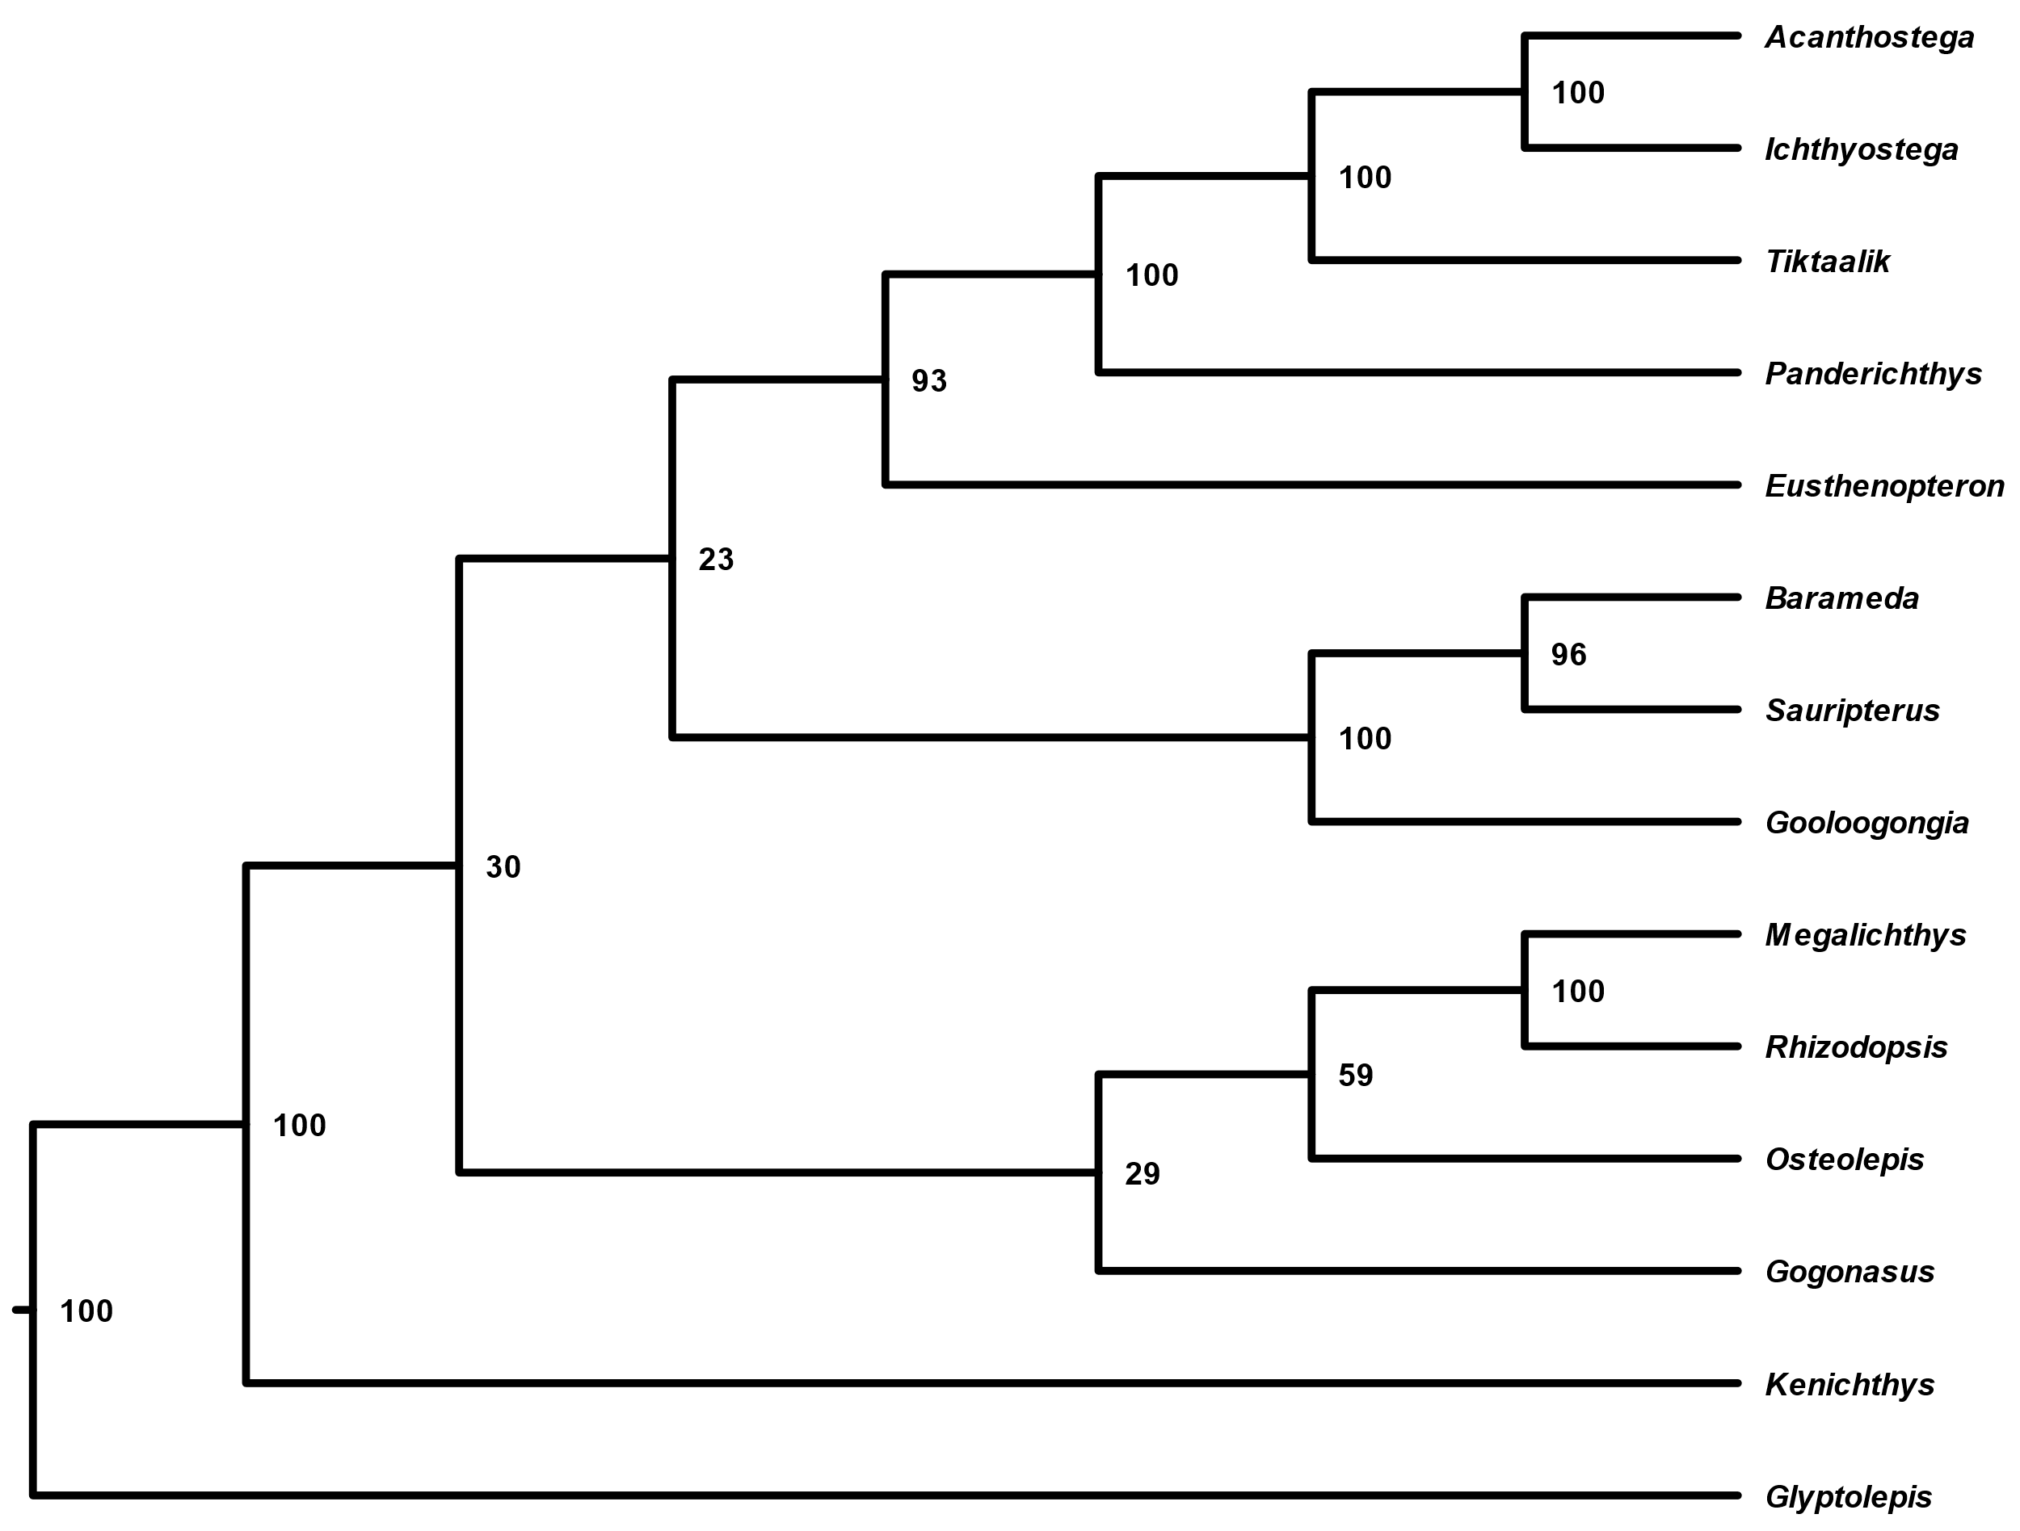

Fig. 1. The phylogenetic tree inferred using Friedman et al.’s (2007) matrix. Node values represent percent node posterior probabilities. Note that the hypothesized relationship between Megalichthyiformes, Rhizodontida, and Eotetrapodiformes have low support (30 and 23). We used FigTree to produce this figure.

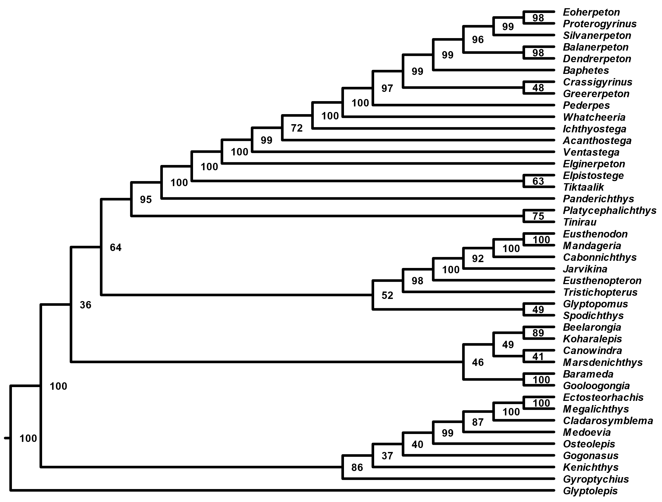

Fig. 2. The phylogenetic tree inferred using Swartz’s (2012) matrix. Node values represent posterior probabilities (%). The sister taxon relationship between a group of canowindrids and rhizodontids and Eotetrapodiformes has low support (36).

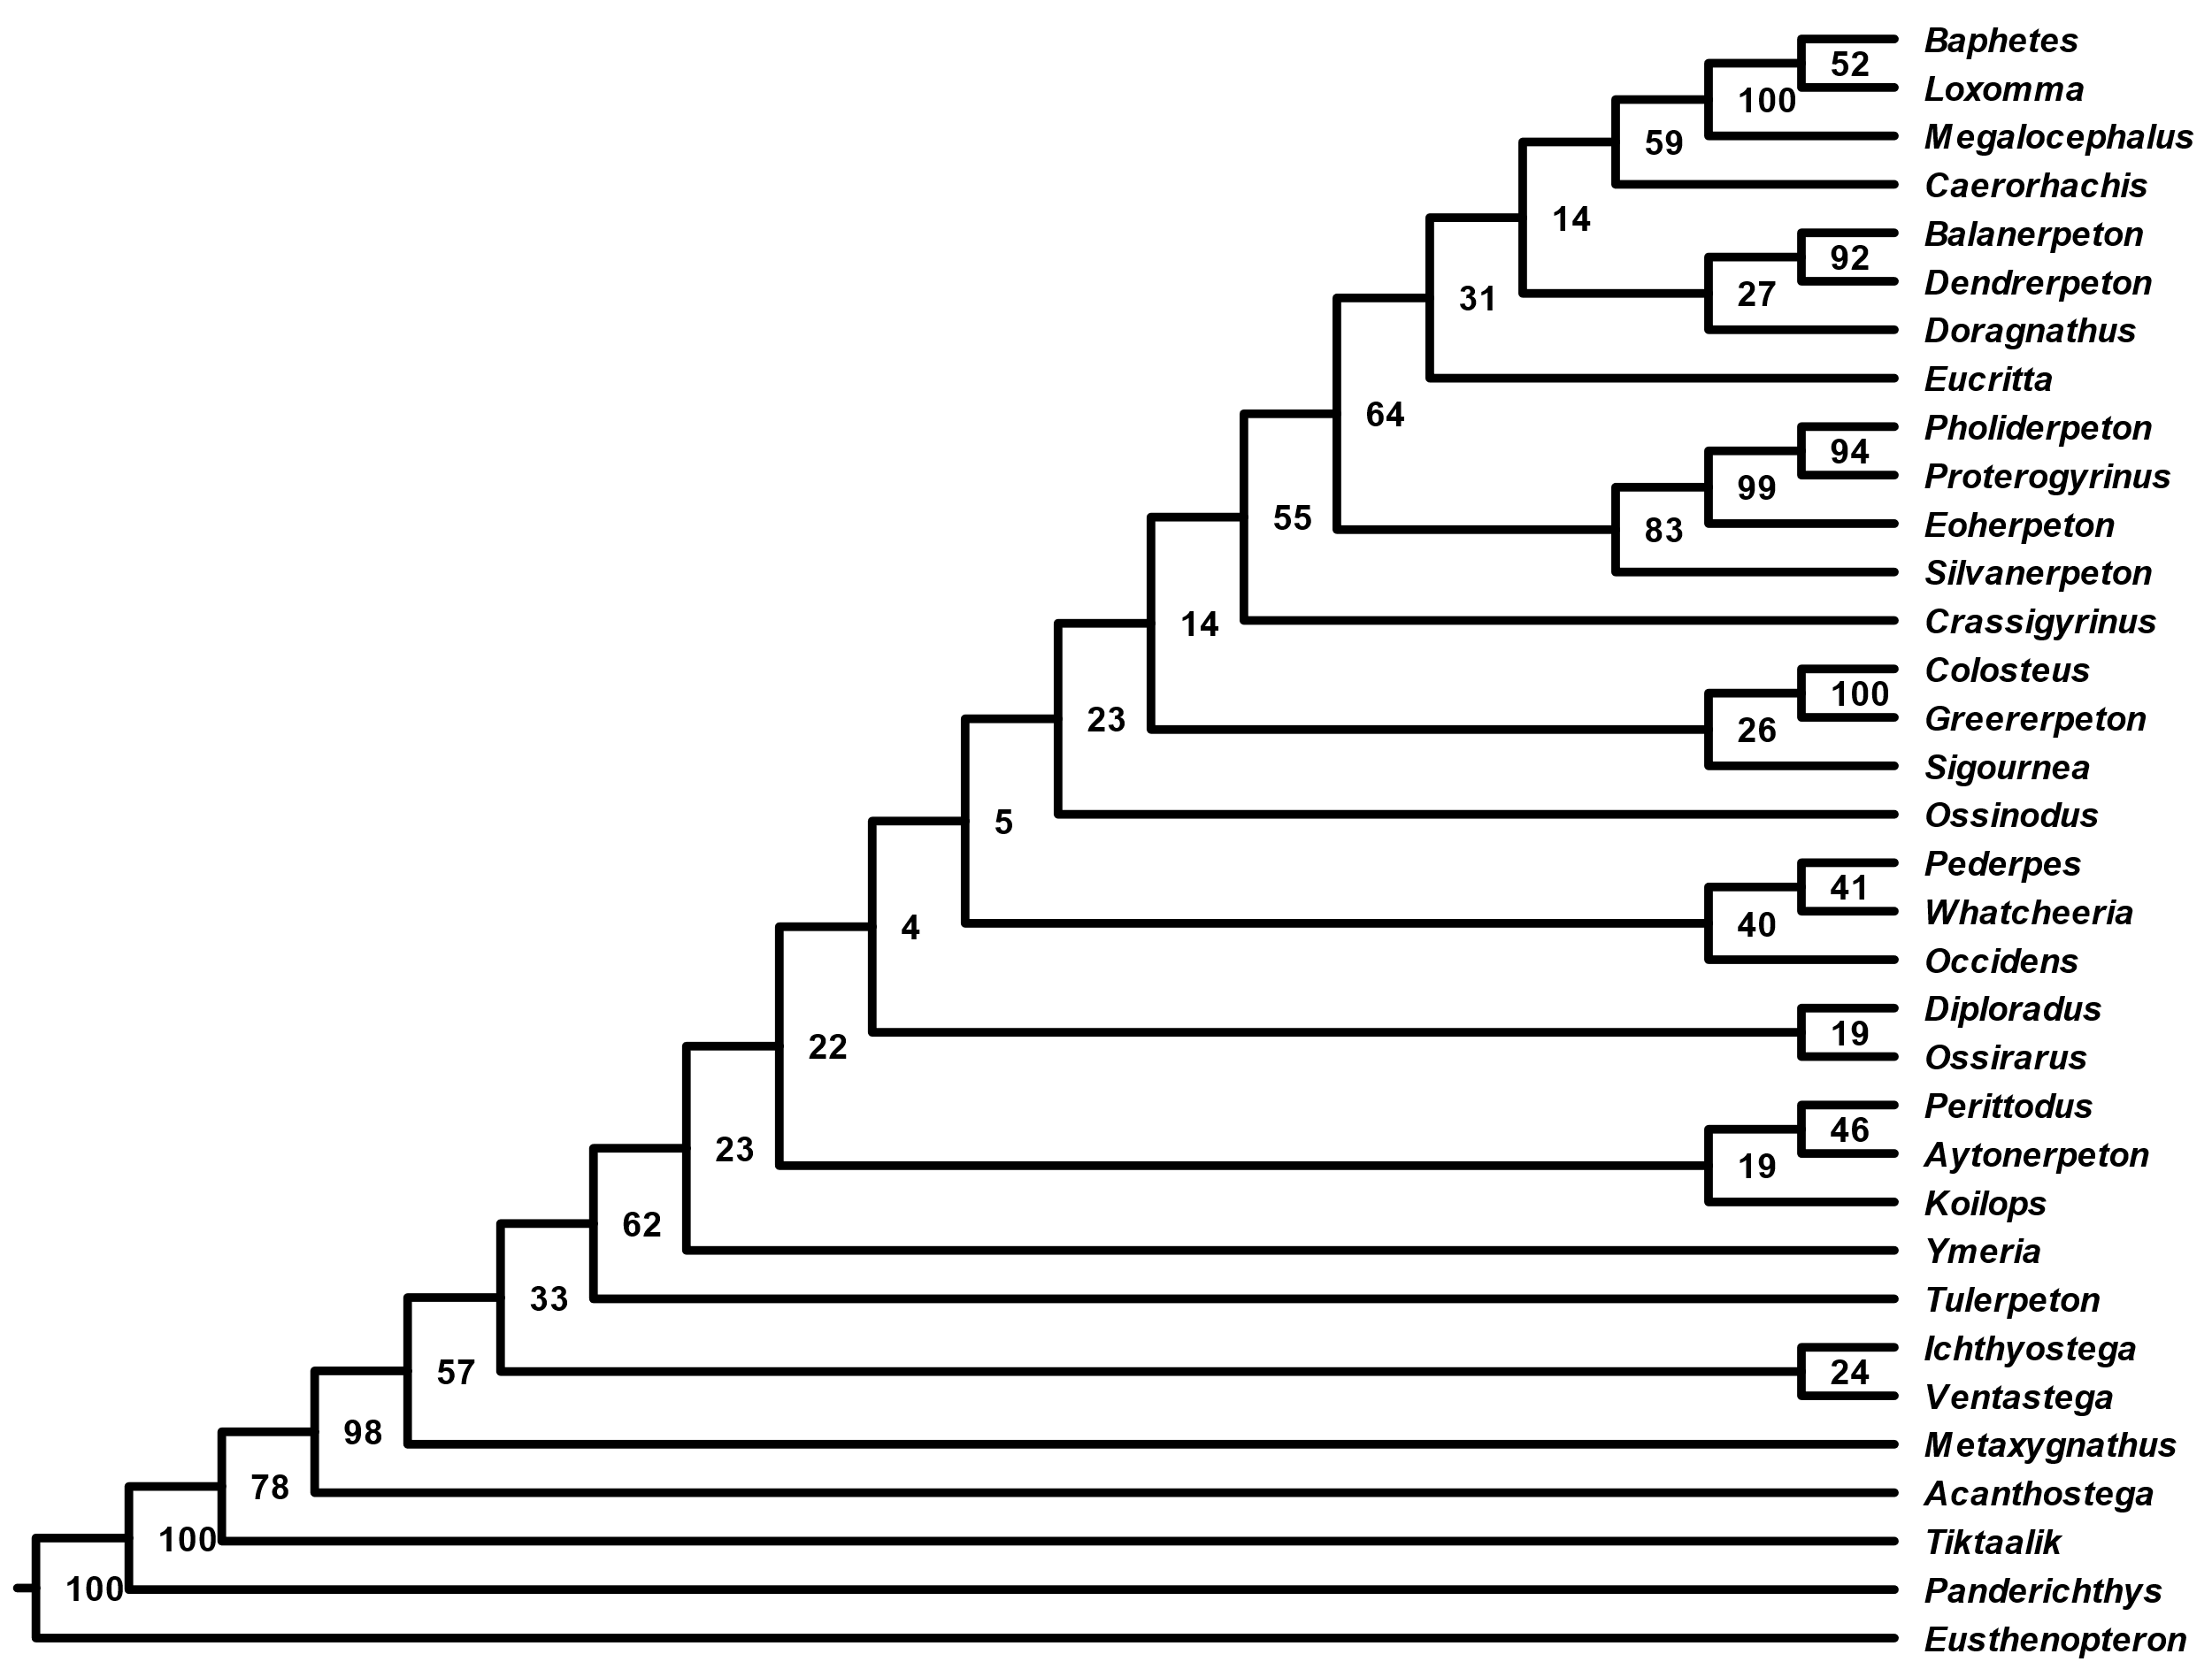

Fig. 3. The phylogenetic tree inferred using Clack et al.’s (2017) matrix. Node values represent posterior probabilities (%). Note the low support for multiple backbone nodes.

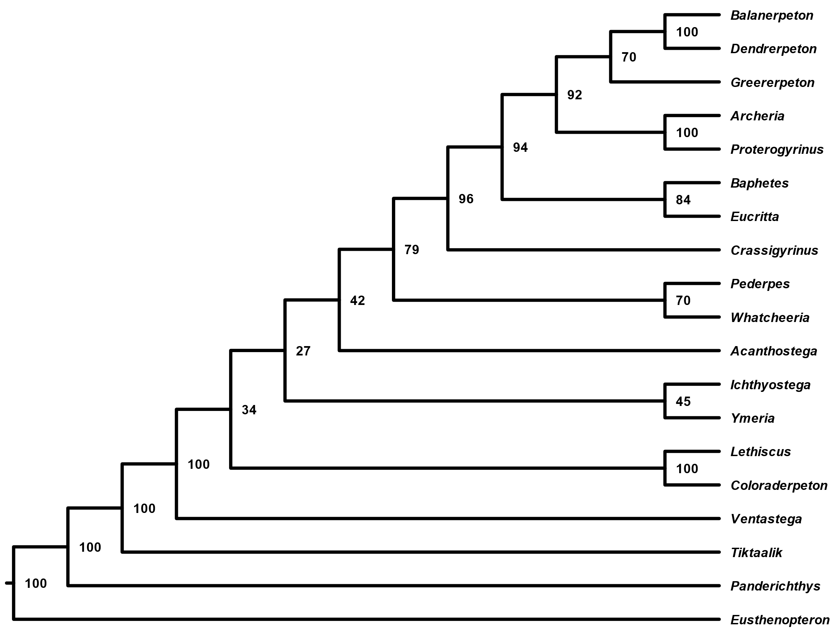

Fig. 4. The phylogenetic tree inferred using Pardo et al.’s (2017) matrix. Node values represent posterior probabilities (%). Note the low support for some backbone nodes (34, 27, and 42).

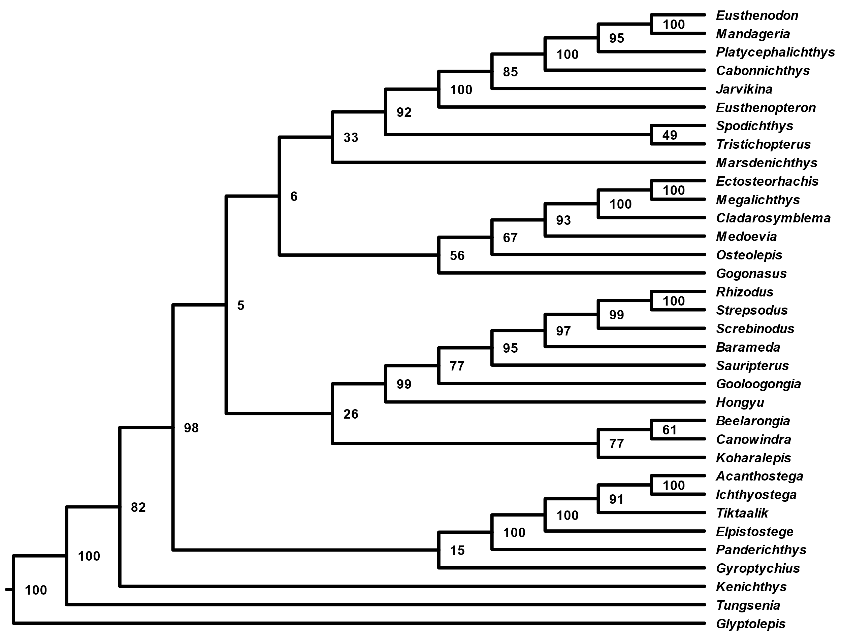

Fig. 5. The phylogenetic tree inferred using Zhu et al.’s (2017) matrix. Node values represent posterior probabilities (%). Note that the hypothesized relationship between Canowindridae, Rhizodontida, Megalichthyiformes, and Tristichopteridae have low support (5, 6, and 26). This unconventional topology shows an early divergence of Elpistostegalia from the rest of stem-tetrapods.

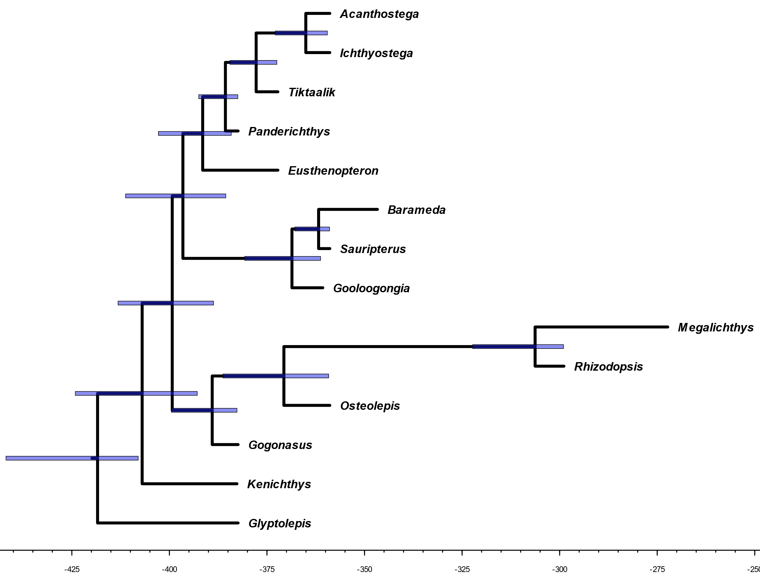

Fig. 6. The time-scaled phylogenetic tree inferred using Friedman et al.’s (2007) matrix. Node bars represent 95% highest posterior density (HPD) of node age estimates.

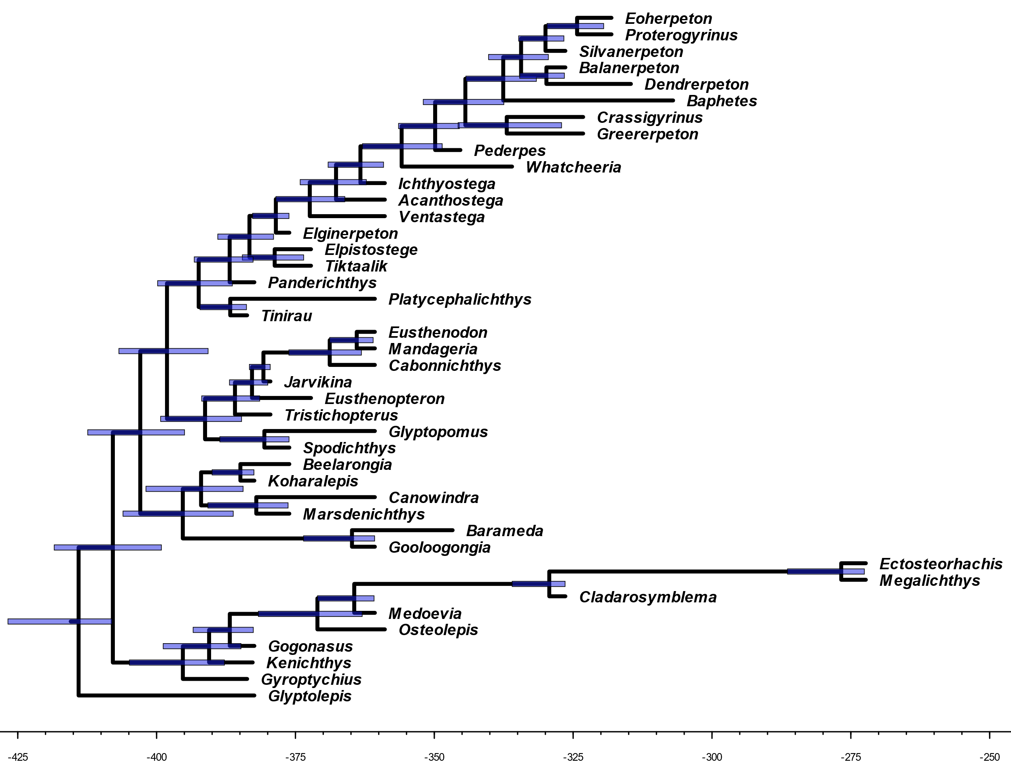

Fig. 7. The time-scaled phylogenetic tree inferred using Swartz’s (2012) matrix. Node bars represent 95% highest posterior density (HPD) of node age estimates.

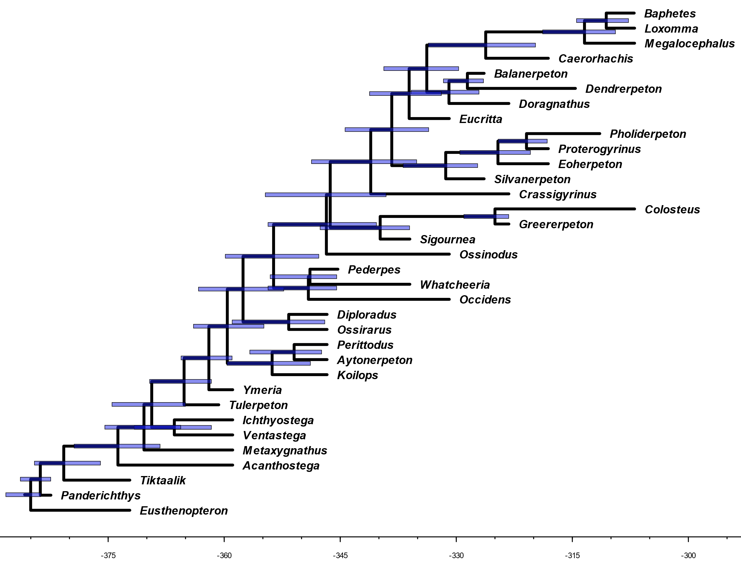

Fig. 8. The time-scaled phylogenetic tree inferred using Clack et al.’s (2017) matrix. Node bars represent 95% highest posterior density (HPD) of node age estimates.

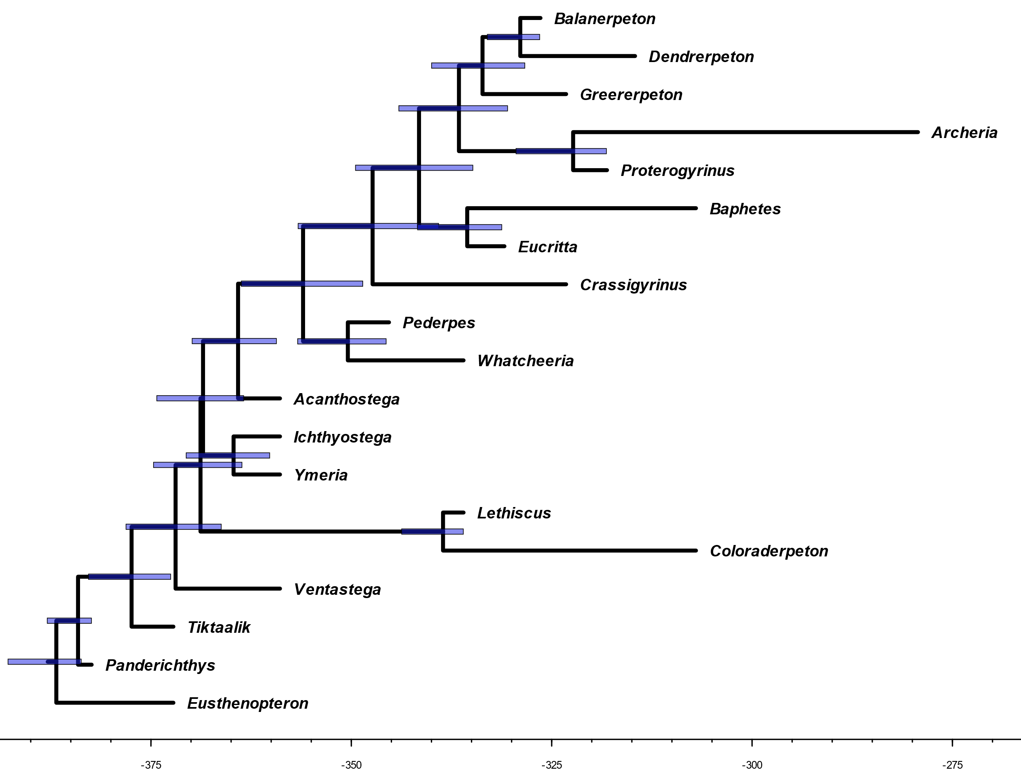

Fig. 9. The time-scaled phylogenetic tree inferred using Pardo et al.’s (2017) matrix. Node bars represent 95% highest posterior density (HPD) of node age estimates.

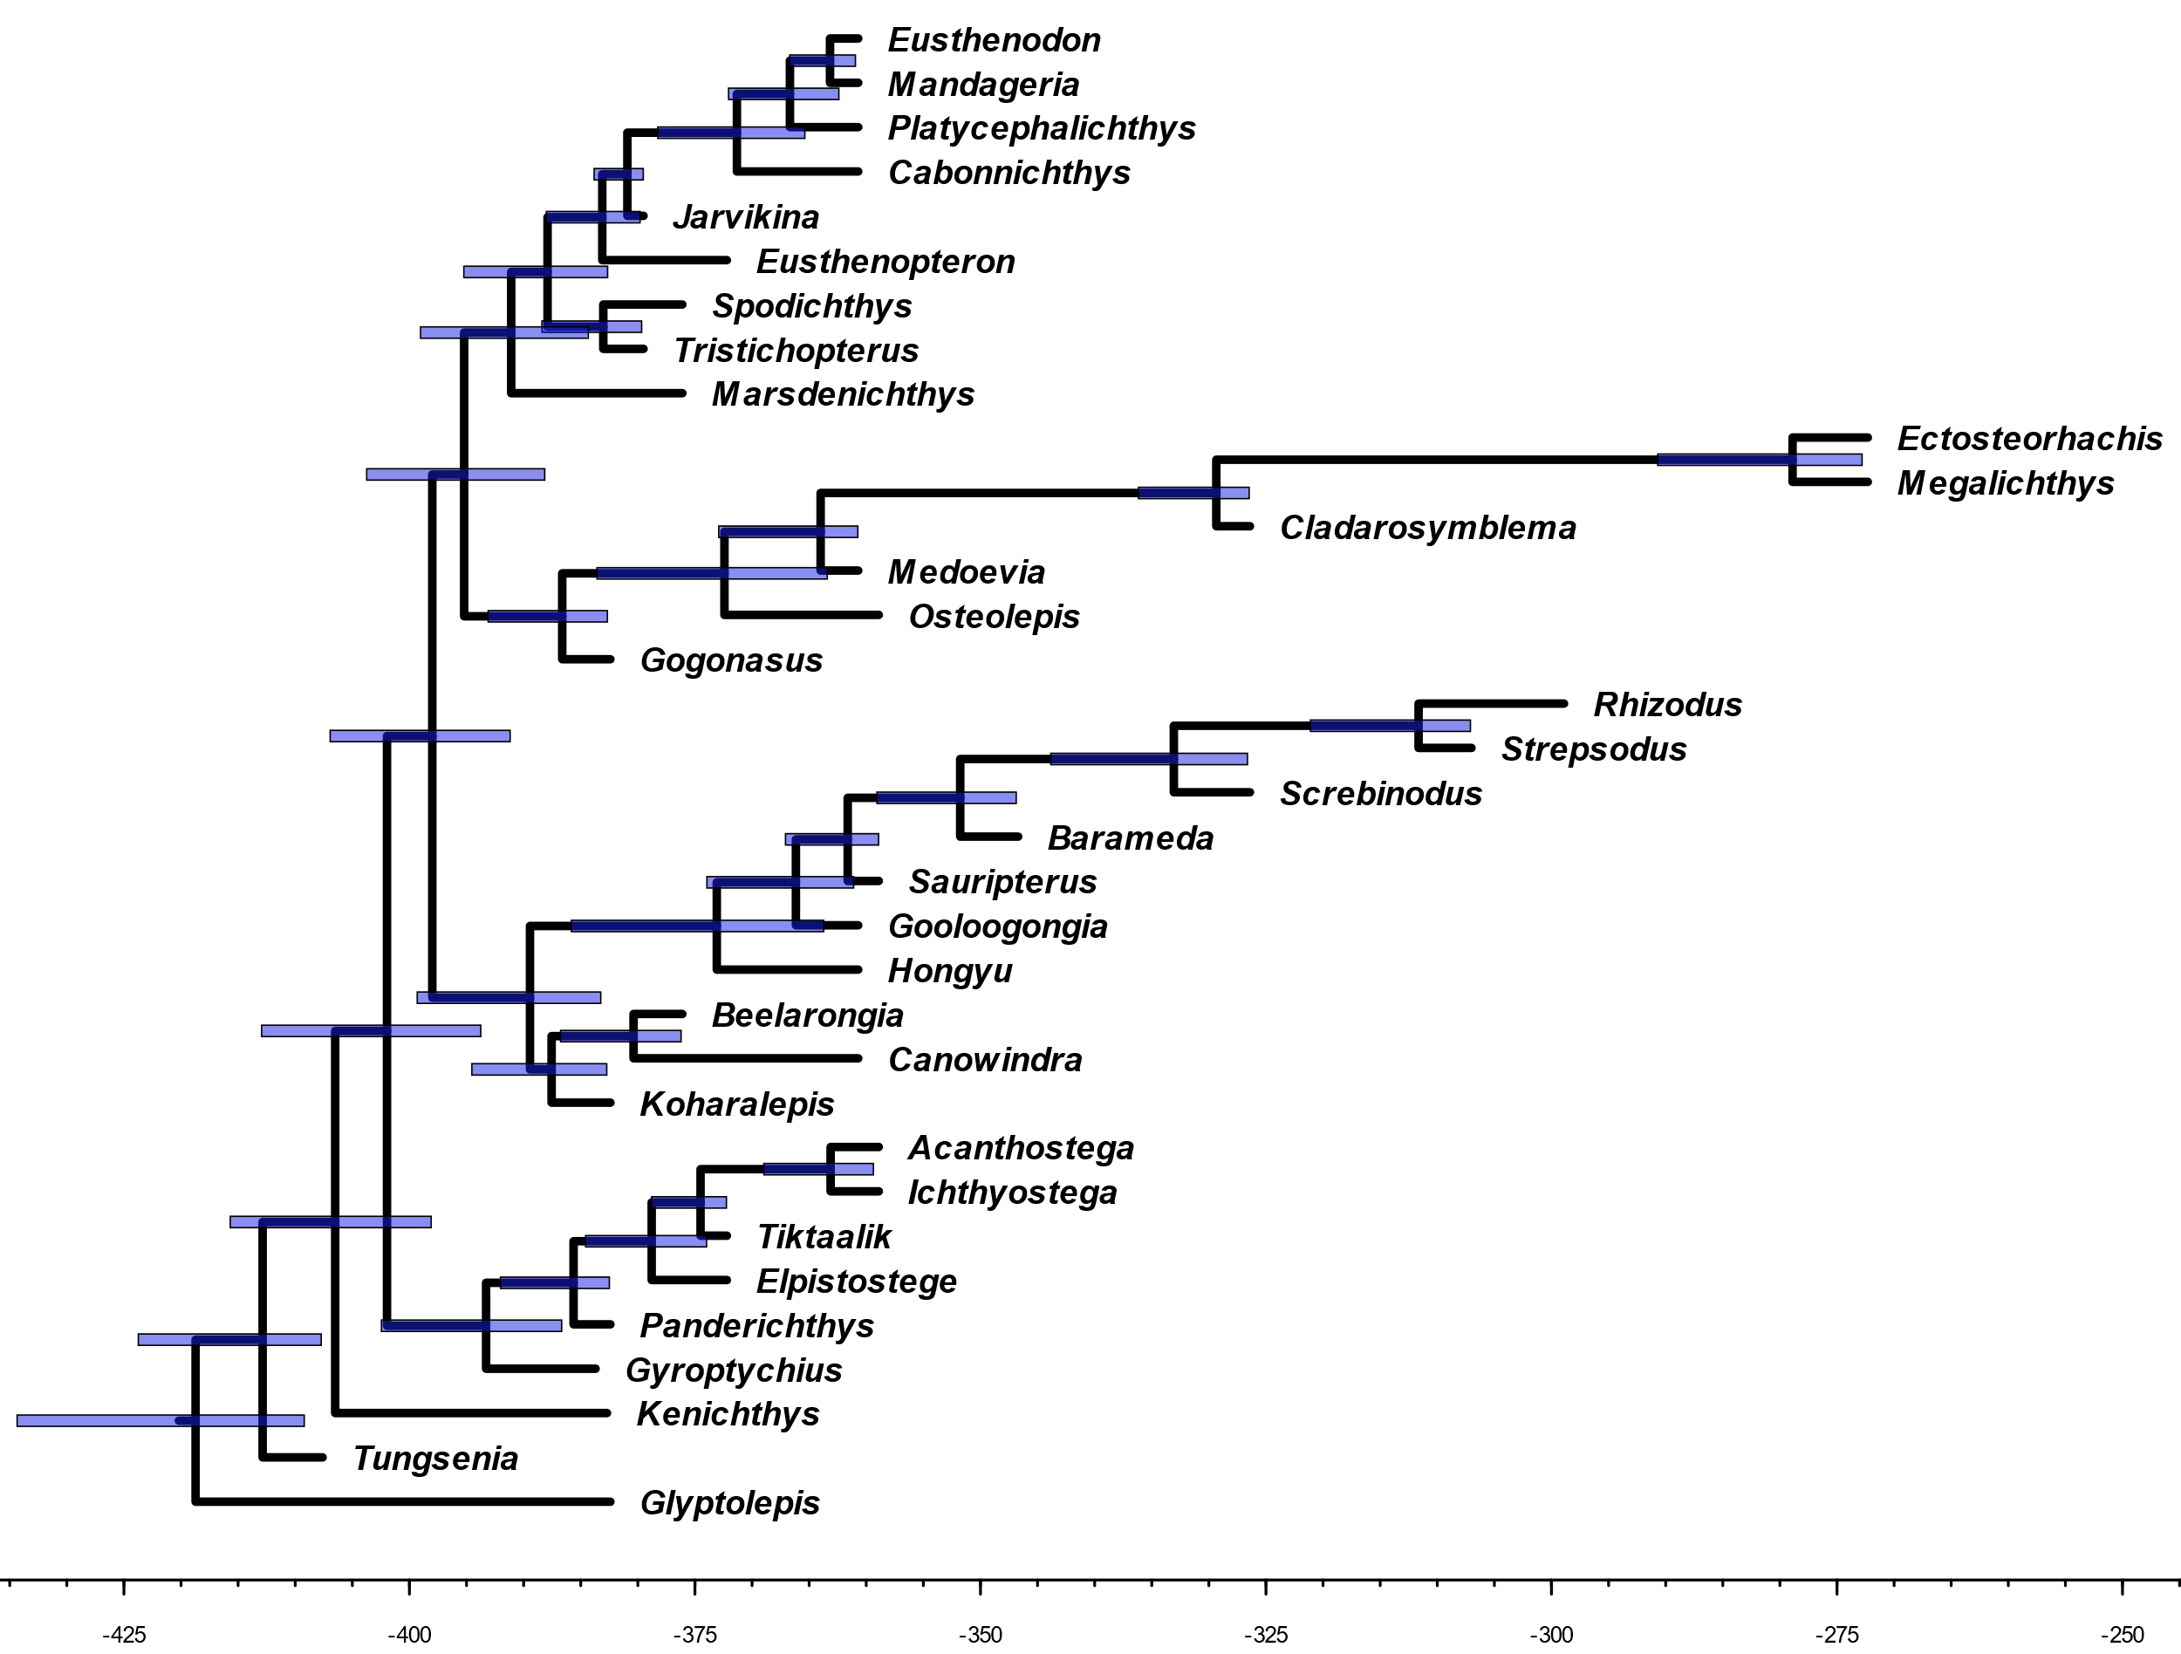

Fig. 10. The time-scaled phylogenetic tree inferred using Zhu et al.’s (2017) matrix. Node bars represent 95% highest posterior density (HPD) of node age estimates.

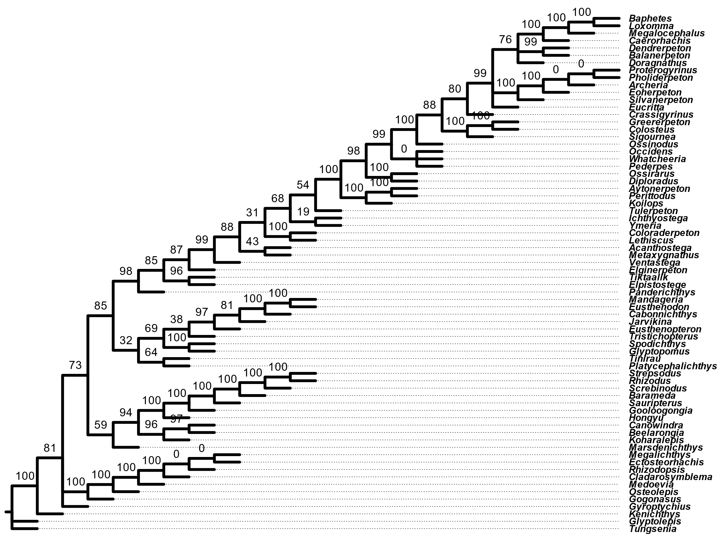

Fig. 11. Most of the supertree’s confidence values at internal branches are above 50. However, there are some zeroes in regions that are otherwise well-supported in the source trees.

Fig. 12. A) Scatter-plot of the average dispersal rates over the regional-level formation counts for each branch of the phylogeny, using the Western Gondwana route scenario. Points colored by the dispersal rate being above or below two standard deviations greater than the average rate across the tree. B) Histogram of the bootstrapped U-statistics with values outside of the 95% confidence interval grayed out. The median and null expected U-statistics are indicated by the red and blue dotted lines, respectively. The null expected U-statistic is based on the null hypothesis that 50% of the regional-level formation counts with low dispersal rates will rank higher than formation counts with higher rates.

Fig. 13. A) Scatter-plot of the average dispersal rates over the regional-level formation counts for each branch of the phylogeny, using the direct route scenario. Points colored by the dispersal rate being above or below two standard deviations greater than the average rate across the tree. B) Histogram of the bootstrapped U-statistics with values outside of the 95% confidence interval grayed out. The median and null expected U-statistics are indicated by the red and blue dotted lines, respectively. The null expected U-statistic is based on the null hypothesis that 50% of the regional-level formation counts with low dispersal rates will rank higher than formation counts with higher rates.

Supplementary files description

1. Supertree

1.1. Data

- tree_2007_Friedman_etal.NWK
- tree_2012_Swartz.NWK
- tree_2017_Clack_etal.NWK
- tree_2017_Pardo_etal.NWK
- tree_2017_Zhu_etal.NWK
We used these cladograms in Newick format when comparing the published source tree topologies with the supertree topology.

- tree_matrix_2007_Friedman_etal.NEX
- tree_matrix_2012_Swartz.NEX
- tree_matrix_2017_Clack_etal.NEX
- tree_matrix_2017_Pardo_etal.NEX
- tree_matrix_2017_Zhu_etal.NEX
These NEXUS files contain data matrices and MrBayes blocks.

1.2. Analysis

- tree_mrbayes_output_2007_Friedman_etal
- tree_mrbayes_output_2012_Swartz
- tree_mrbayes_output_2017_Clack_etal
- tree_mrbayes_output_2017_Pardo_etal
- tree_mrbayes_output_2017_Zhu_etal
These folders contain MrBayes outputs for each inference, including maximum clade credibility trees.

- tree_phydstar_supertree_rooted.trees
These NEXUS files contain the final rooted supertree.

- tree_R_compare_trees.R
We used the R script above to calculate normalized Robinson-Foulds distances between the supertree and the published source trees.

- tree_R_root_tree.R
We used the R script above to root the supertree and save it in a NEXUS format.

- tree_sdm.txt
We used the PHYLIP file above, which contains all five maximum clade credibility trees to build the distance supermatrix.

- tree_sdm_output_mat.txt
This is the distance supermatrix.

1.3. Publication

- Gardner.etal.CRPalevol.Fig1.SupertreeFinal.v1.0.pptx
We used Microsoft PowerPoint to prepare Figure 1.

- Gardner.etal.CRPalevol.Fig1.SupertreeRCode.v1.0.R
We used the R script above to plot our supertree against the international geological time scale.

2. Phylogeography

2.1. Data

- Gardner.etal.FormationCounts.xlsx
Regional- and stage-level formation counts from PBDB and Benton et al. (2013)

- Gardner.etal.GeoData.xlsx
Paleocoordinate data entries from the PBDB.

2.2. Analysis

- Gardner.etal.VRCalc.xlsx
Calculating dispersal rate for each branch of the phylogeny.

- Gardner.etal.VRRunComparisons.xlsx
Comparing the ancestral states and rate scalars among the three independent variable rates runs.

- RegCount_WestGond_boot.R
Bootstrapping Mann-Whitney U-test analyses using regional-level formation counts from Western Gondwana route scenario.

- RegCount_NorthEur_boot.R
Bootstrapping Mann-Whitney U-test analyses using regional-level formation counts from Northern Euramerica route scenario.

- RegCount_Direct_boot.R
Bootstrapping Mann-Whitney U-test analyses using regional-level formation counts from direct route scenario.

References

Ahlberg, P.E., Johanson, Z., 1997. Second tristichopterid (Sarcopterygii, Osteolepiformes) from the Upper Devonian of Canowindra, New South Wales, Australia, and phylogeny of the Tristichopteridae. J. Vert. Paleontol. 17, 653–673. https://doi.org/10.1080/02724634.1997.10011015
Andrews, S.M., 1985. Rhizodont crossopterygian fish from the Dinantian of Foulden, Berwickshire, Scotland, with a re-evaluation of this group. Earth Env. Sci. T. R. So. 76, 67–95. https://doi.org/10.1017/S0263593300010324
Ayres, D.L., Darling, A., Zwickl, D.J., Beerli, P., Holder, M.T., Lewis, P.O., Huelsenbeck, J.P., Ronquist, F., Swofford, D.L., Cummings, M.P., Rambaut, A., Suchard, M.A., 2012. BEAGLE: An application programming interface and high-performance computing library for statistical phylogenetics. Syst. Biol. 61, 170–173. https://doi.org/10.1093/sysbio/syr100
Bell, M.A., Lloyd, G.T., 2015. strap: An R package for plotting phylogenies against stratigraphy and assessing their stratigraphic congruence. Palaeontology 58, 379–389. https://doi.org/10.1111/pala.12142
Benton, M.J., Ruta, M., Dunhill, A.M., Sakamoto, M., 2013. The first half of tetrapod evolution, sampling proxies, and fossil record quality. ‎Palaeogeogr. Palaeoclimatol. Palaeoecol., Vertebrate palaeobiodiversity patterns and the impact of sampling bias 372, 18–41. https://doi.org/10.1016/j.palaeo.2012.09.005
Benton, M.J., Donoghue, P.C.J., Asher, R.J., Friedman, M., Near, T.J., Vinther, J., 2015. Constraints on the timescale of animal evolutionary history. Palaeontol. Electron. 18, 1–106. https://doi.org/10.26879/424
Bishop, P.J., 2013. A second species of Tristichopterus (Sarcopterygii: Tristichopteridae), from the Upper Devonian of the Baltic Region. Mem. Queensl. Mus. 56, 305–309.
Boisvert, C.A., Mark-Kurik, E., Ahlberg, P.E., 2008. The pectoral fin of Panderichthys and the origin of digits. Nature 456, 636–638. https://doi.org/10.1038/nature07339
Clack, J.A., Bennett, C.E., Carpenter, D.K., Davies, S.J., Fraser, N.C., Kearsey, T.I., Marshall, J.E.A., Millward, D., Otoo, B.K.A., Reeves, E.J., Ross, A.J., Ruta, M., Smithson, K.Z., Smithson, T.R., Walsh, S.A., 2017. Phylogenetic and environmental context of a Tournaisian tetrapod fauna. Nat. Ecol. Evol. 1, 0002. https://doi.org/10.1038/s41559-016-0002
Clement, G., 2002. Large Tristichopteridae (Sarcopterygii, Tetrapodomorpha) from the Late Famennian Evieux Formation of Belgium. Palaeontology 45, 577–593. https://doi.org/10.1111/1475-4983.00250
Clement, G., Snitting, D., Ahlberg, P.E., 2009. A new tristichopterid (Sarcopterygii, Tetrapodomorpha) from the Upper Famennian Evieux Formation (upper Devonian) of Belgium. Palaeontology 52, 823–836. https://doi.org/10.1111/j.1475-4983.2009.00876.x
Criscuolo, A., Gascuel, O., 2008. Fast NJ-like algorithms to deal with incomplete distance matrices. BMC Bioinformatics 9, 166. https://doi.org/10.1186/1471-2105-9-166
Criscuolo, A., Berry, V., Douzery, E.J.P., Gascuel, O., 2006. SDM: A fast distance-based approach for (super)tree building in phylogenomics. Syst. Biol. 55, 740–755. https://doi.org/10.1080/10635150600969872
Didier, G., Laurin, M., 2018. Exact distribution of divergence times from fossil ages and topologies. bioRxiv 490003. https://doi.org/10.1101/490003
Didier, G., Fau, M., Laurin, M., 2017. Likelihood of tree topologies with fossils and diversification rate estimation. Syst. Biol. 66, 964–987. https://doi.org/10.1093/sysbio/syx045
Didier, G., Royer-Carenzi, M., Laurin, M., 2012. The reconstructed evolutionary process with the fossil record. J. Theor. Biol. 315, 26–37. https://doi.org/10.1016/j.jtbi.2012.08.046
Fox, R.C., Campbell, K.S.W., Barwick, R.E., Long, J.A., 1995. A new osteolepiform fish from the lower Carboniferous Raymond Formation, Drummond Basin, Queensland. Mem. Queensl. Mus. 38, 97–221.
Friedman, M., Coates, M.I., Anderson, P., 2007. First discovery of a primitive coelacanth fin fills a major gap in the evolution of lobed fins and limbs. Evol. Dev. 9, 329–337. https://doi.org/10.1111/j.1525-142X.2007.00169.x
Gascuel, O., 1997. Concerning the NJ algorithm and its unweighted version, UNJ, in: Roberts, F., Rzhetsky, A. (Eds.), Mathematical Hierarchies and Biology. American Mathematical Soc., Providence, RI, pp. 149–170.
Gavryushkina, A., Welch, D., Stadler, T., Drummond, A.J., 2014. Bayesian inference of sampled ancestor trees for epidemiology and fossil calibration. PLoS Comput. Biol. 10, e1003919. https://doi.org/10.1371/journal.pcbi.1003919
Gelman, A., Rubin, D.B., 1992. Inference from iterative simulation using multiple sequences. Stat. Sci. 7, 457–472.
Geyer, C.J., 1991. Markov chain Monte Carlo maximum likelihood, in: Kerimidas, E.M. (Ed.), Computing Science and Statistics: Proceedings of the 23rd Symposium on the Interface. Interface Foundation, Fairfax Station, VA, pp. 156–163.
Guénoche, A., Garreta, H., 2000. Can we have confidence in a tree representation? in: JOBIM. https://doi.org/10.1007/3-540-45727-5_5
Harrison, L.B., Larsson, H.C.E., 2015. Among-character rate variation distributions in phylogenetic analysis of discrete morphological characters. Syst. Biol. 64, 307–324. https://doi.org/10.1093/sysbio/syu098
Hastings, W.K., 1970. Monte Carlo sampling methods using Markov chains and their applications. Biometrika 57, 97–109. https://doi.org/10.1093/biomet/57.1.97
Heath, T.A., Huelsenbeck, J.P., Stadler, T., 2014. The fossilized birth–death process for coherent calibration of divergence-time estimates. Proc. Natl. Acad. Sci. U.S.A. 111, E2957–E2966. https://doi.org/10.1073/pnas.1319091111
Holland, T., Long, J., Snitting, D., 2010. New information on the enigmatic tetrapodomorph fish Marsdenichthys longioccipitus (Long, 1985). J. Vert. Paleontol. 30, 68–77. https://doi.org/10.1080/02724630903409105
Johanson, Z., Ahlberg, P.E., 1997. A new tristichopterid (Osteolepiformes: Sarcopterygii) from the Mandagery Sandstone (Late Devonian, Famennian) near Canowindra, NSW, Australia. Palaeontology 88, 39–68. https://doi.org/10.1017/S0263593300002303
Johanson, Z., Ahlberg, P.E., 1998. A complete primitive rhizodont from Australia. Nature 394, 569–573. https://doi.org/10.1038/29058
Lakner, C., van der Mark, P., Huelsenbeck, J.P., Larget, B., Ronquist, F., 2008. Efficiency of Markov chain Monte Carlo tree proposals in Bayesian phylogenetics. Syst. Biol. 57, 86–103. https://doi.org/10.1080/10635150801886156
Lebedev, O.A., 1995. Morphology of a new osteolepidid fish from Russia. Bull. Mus. Nat. Hist. Natur., Sect. C 17, 287–341.
Lebedev, O.A., Lukševičs, E., 2017. Glyptopomus bystrowi (Gross, 1941), an “osteolepidid” tetrapodomorph from the Upper Famennian (Upper Devonian) of Latvia and Central Russia. Palaeobio. Palaeoenv. 97, 615–632. https://doi.org/10.1007/s12549-016-0249-9
Lebedev, O.A., Lukševičs, E., Zakharenko, G.V., 2010. Palaeozoogeographical connections of the Devonian vertebrate communities of the Baltica Province. Part II. Late Devonian. Palaeoworld, Middle Palaeozoic vertebrate biogeography, palaeogeography and climate (IGCP Project 491) 19, 108–128. https://doi.org/10.1016/j.palwor.2009.12.003
Lepage, T., Bryant, D., Philippe, H., Lartillot, N., 2007. A general comparison of relaxed molecular clock models. Mol. Biol. Evol. 24, 2669–2680. https://doi.org/10.1093/molbev/msm193
Lewis, P.O., 2001. A likelihood approach to estimating phylogeny from discrete morphological character data. Syst. Biol. 50, 913–925. https://doi.org/10.1080/106351501753462876
Long, J.A., 1987. An unusual osteolepiform fish from the Late Devonian of Victoria, Australia. Palaeontology 30, 839–852.
Long, J.A., Young, G.C., Holland, T., Senden, T.J., Fitzgerald, E.M.G., 2006. An exceptional Devonian fish from Australia sheds light on tetrapod origins. Nature 444, 199–202. https://doi.org/10.1038/nature05243
Metropolis, N., Rosenbluth, A.W., Rosenbluth, M.N., Teller, A.H., Teller, E., 1953. Equation of state calculations by fast computing machines. J. Chem. Phys. 21, 1087–1092. https://doi.org/10.1063/1.1699114
Newman, M.J., Mark-Kurik, E., Blaauwen, J.L.D., Zupiņš, I., 2015. Scottish Middle Devonian fishes in Estonia. Scot. J. Geol. 51, 141–147. https://doi.org/10.1144/sjg2014-006
Pagel, M., 1999. Inferring the historical patterns of biological evolution. Nature 401, 877–884. https://doi.org/10.1038/44766
Paradis, E., Schliep, K., 2019. ape 5.0: an environment for modern phylogenetics and evolutionary analyses in R. Bioinformatics 35, 526–528. https://doi.org/10.1093/bioinformatics/bty633
Pardo, J.D., Szostakiwskyj, M., Ahlberg, P.E., Anderson, J.S., 2017. Hidden morphological diversity among early tetrapods. Nature 546, 642–645. https://doi.org/10.1038/nature22966
Parker, K., Warren, A., Johanson, Z., 2005. Strepsodus (Rhizodontida, Sarcopterygii) pectoral elements from the Lower Carboniferous Ducabrook Formation, Queensland, Australia. J. Vert. Paleontol. 25, 46–62. https://doi.org/10.1671/0272-4634(2005)025[0046:SRSPEF]2.0.CO;2
R Core Team., 2018. R: A language and environment for statistical computing. Vienna: R Foundation for Statistical Computing. https://www.R-project.org/ (accessed 20 December 2018)
Rambaut, A., 2017. FigTree-version 1.4.3, a graphical viewer of phylogenetic trees. http://tree.bio.ed.ac.uk/software/figtree/ (accessed 4 October 2016)
Revell, L.J., 2012. phytools: An R package for phylogenetic comparative biology (and other things). Methods Ecol. Evol. 3, 217–223. https://doi.org/10.1111/j.2041-210X.2011.00169.x
Rineau, V., Bagils, R.Z., Laurin, M., 2018. Impact of errors on cladistic inference: Simulation-based comparison between parsimony and three-taxon analysis. Contrib. Zool. 87, 25–40. https://doi.org/10.1163/18759866-08701003
Rineau, V., Grand, A., Zaragüeta, R., Laurin, M., 2015. Experimental systematics: Sensitivity of cladistic methods to polarization and character ordering schemes. Contrib. Zool. 84, 129–148. https://doi.org/10.1163/18759866-08402003
Robinson, D.F., Foulds, L.R., 1981. Comparison of phylogenetic trees. Math. Biosci. 53, 131–147. https://doi.org/10.1016/0025-5564(81)90043-2
Ronquist, F., Klopfstein, S., Vilhelmsen, L., Schulmeister, S., Murray, D.L., Rasnitsyn, A.P., 2012a. A total-evidence approach to dating with fossils, applied to the early radiation of the Hymenoptera. Syst. Biol. 61, 973–999. https://doi.org/10.1093/sysbio/sys058
Ronquist, F., Teslenko, M., van der Mark, P., Ayres, D.L., Darling, A., Höhna, S., Larget, B., Liu, L., Suchard, M.A., Huelsenbeck, J.P., 2012b. MrBayes 3.2: Efficient Bayesian phylogenetic inference and model choice across a large model space. Syst. Biol. 61, 539–542. https://doi.org/10.1093/sysbio/sys029
Schliep, K.P., 2011. phangorn: Phylogenetic analysis in R. Bioinformatics 27, 592–593. https://doi.org/10.1093/bioinformatics/btq706
Snitting, D., 2008. A redescription of the anatomy of the Late Devonian Spodichthys buetleri Jarvik, 1985 (Sarcopterygii, Tetrapodomorpha) from East Greenland. J. Vert. Paleontol. 28, 637–655. https://doi.org/10.1671/0272-4634(2008)28[637:AROTAO]2.0.CO;2
Stadler, T., 2010. Sampling-through-time in birth–death trees. J. Theor. Biol. 267, 396–404. https://doi.org/10.1016/j.jtbi.2010.09.010
Swartz, B., 2012. A marine stem-tetrapod from the Devonian of Western North America. PLoS ONE 7, e33683. https://doi.org/10.1371/journal.pone.0033683
Thomson, K.S., 1973. Observations on a new rhipidistian fish from the Upper Devonian of Australia. Palaeontogr. Abt. A 143, 209–220.
Urbanek, S., Horner, J., 2015. Cairo: R graphics device using cairo graphics library for creating high-quality bitmap (PNG, JPEG, TIFF), vector (PDF, SVG, PostScript) and display (X11 and Win32) output. https://CRAN.R-project.org/package=Cairo (accessed 27 January 2019).
Yang, Z., 1994. Maximum likelihood phylogenetic estimation from DNA sequences with variable rates over sites: Approximate methods. J. Mol. Evol. 39, 306–314. https://doi.org/10.1007/BF00160154
Young, G.C., Long, J.A., Ritchie, A., 1992. Crossopterygian fishes from the Devonian of Antarctica: Systematics, relationships and biogeographic significance. Rec. Aus. Mus. Suppl. 14, 1–77. https://doi.org/10.3853/j.0812-7387.14.1992.90
Zhang, C., Stadler, T., Klopfstein, S., Heath, T.A., Ronquist, F., 2016. Total-evidence dating under the fossilized birth–death process. Syst. Biol. 65, 228–249. https://doi.org/10.1093/sysbio/syv080
Zhu, M., Ahlberg, P.E., Zhao, W.-J., Jia, L.-T., 2017. A Devonian tetrapod-like fish reveals substantial parallelism in stem tetrapod evolution. Nat. Ecol. Evol. 1, 1470–1476. https://doi.org/10.1038/s41559-017-0293-5

